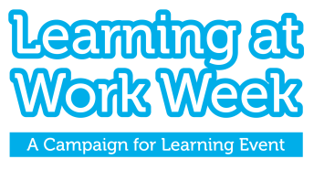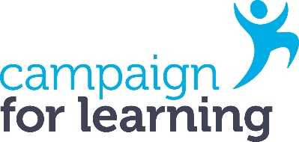
The Campaign for Learning
Learning at Work Week Impact Award
'Supporting Business and Organisational Goals'
Learning at Work Week offers an opportunity to support business goals and address organisational needs through, for example, designing special activities, launching new learning initiatives, testing new approaches and using the week to reinforce business values and communicate important messages.
The Campaign for Learning Impact Award for Learning at Work Week recognises organisations that best demonstrate how their Learning at Work Week activities contributed to supporting their business and organisational goals. Judges will look for evidence of how you integrated your business or departmental goals into the planning and implementation of your Learning at Work Week activities. Judges are also keen to see how you have evaluated the impact of your activities, and how these have resulted in and/or will lead to longer term benefits. The judging criteria can be found on the last page of this entry form.
The award is free to enter and the deadline for submissions is Friday 24 July 2026. Please submit your application along with graphics, photos or media if available. Non-submission of graphics, photos or media is not a disadvantage.
The entry form can be found below. Please ensure to upload this via the webform.
About you and your organisation (please note: this section is for information only and will not be part of the judging criteria)
Name
Job title
Organisation
Address
Contact number
Email
How many employees do you have?
How many employees participated in the event?
Section 1: Objectives (3 marks overall)
Which business goals or organisational needs did you support through Learning at Work Week? (100 words max)
What were your objectives for Learning at Work Week and how did these support your identified business goals and needs? (150 words max)

Section 2: Learning at Work Week activities (6 marks overall)
What activities did you design and deliver for Learning at Work Week and who were they aimed at in your organisation? (100 words max) (3 marks)

How did the activities support the achievement of your Learning at Work Week objectives? (150 words max) (3 marks)
Section 3: Promotion of your Learning at Work Week activities (6 marks overall)
How did you promote your Learning at Work Week activities? How did you reach and persuade your different workplace audiences to take part – include details of the communication channels used, the messages used to engage your workplace audiences, and the promotional materials used. (200 words max) (3 marks)

How did your promotional activities support your Learning at Work Week objectives? (100 words max) (3 marks)

Section 4: Evaluation and outcomes (9 marks overall)
How were your events and activities monitored and evaluated? (150 words max) (3 marks)
What were the main outcomes and benefits for employees? (150 words max) (3 marks)
What were the main outcomes and benefits for your business or organisation? (150 words max) (3 marks)
Declaration
I confirm that all the information given in support of this entry is correct and I understand that information contained in this entry may be used for publicity purposes by the Campaign for Learning in accordance with the Data Protection Act and with, if required, your permission.
Signature:
Date:
Please submit your entry via the webform.
If you do not receive a confirmation of receipt, please email: info@cflearning.org.uk
Deadline for submissions: Friday 24 July 2026. Incomplete or late submissions will not be considered.
If you are shortlisted, you’ll be notified by Friday 25 September 2026.
The judges’ decision is final and no correspondence or discussion will be entered into about the results.

